

|  |
| --- |
| ASSESSMENT TASK 3  Relational Database Design and Implementation Assignment |

|  |  |  |
| --- | --- | --- |
| **Part-1** |  |  |
| Student | Daniel Davaris 0608458 |  |

TABLE OF CONTENTS

**No table of contents entries found.**

Database Constitution of Criteria

App managing and analysing GNGC course experiences

Database title: (CE Course experience app)

Table-name: Information about courses

* Course number
* The name of offering faculty
* The code of the offering faculty
* List of classes/units covered in the course
* List of skills acquired upon completion of this course

Table -name: Basic information about teachers

* Name
* Gender
* Age
* Areas of expertise
* The year they started teaching in GNGC commencement

Table-name: Basic information about students

* Identified by the unique student ID
* Basic demographic data
  + Year and month of birth
  + Gender
  + Country of birth
  + Start date of enrolment
  + End date of enrolment

And student course experience information

For each time a class/unit of a course is offered, we will create a class roll.

Table-name: Class roll

* Start date (Semester - Quad-semester unit)
* End date (Semester - Quad-semester unit)
* The line the class was offered
* Name of class teacher
* Information about the students enrolled in the class including their final grad(in numerical format- percentage )

Table-name: The students records, their experiences after enrolling in a class for a term

* Overall satisfaction with the class on a scale 1 to 5 (5 is the highest)
* An overall ranking of the class teacher (5 is the highest)

Table-name: The list of skills that the student has acquired from this class

* Each skill needs 2 self-assessment values:
  + The rank of a skill before the class and the rank of the same skill up on the course completion (on a scale of 1-zero knowledge, 2-beginner, 3-intermediate, 4-advanced, 5-professional

Database Design Justification A

Tables

* **Facility Table**
  + **The facility table is simple and only contains a primary key identifier and faculty name. This purpose of this table is to simulate the logical process of a school database in which the facilities i.e. technology, sciences, are a higher category then classes which is a higher category then units. The overall reasoning behind this table is to have a unique ID that can later identify other data from the facility. E.G. find all students in the technology facility**
* **Semesters Table** 
  + **The reasoning behind this table apart from accurately simulating a school database is to link experiences to a specific time period, in this case after the first semester. This table also allows skills, classes and units to be references within a specific semester. The structure includes a start, end and intimidate dates to reference other information. E.G. The classes table includes which semester the class starts and ends in from the semesters table.**
* **Classes Table** 
  + **The class table has the class name, number, id, the class line and other foreign keys referenced from the semesters, units and skills tables. E.G. The classes table stores the name of different classes, the students on the class roll within the classes. The skills, units and related intermediate tables link more directly to the classes table which is why it is situated where it is.**
* **Units Table**
  + **The Units table structure consists of the unit name and unit id but also incorporates links to skills, classes and other foreign tables. This table provides the units for the classes and will be used in the following way. E.G. show all students who take a specific unit.**
* **Skills Table**
  + **The skills table simply features the skill ID and name as well as other foreign keys. The purpose is to store the skills obtained from completing specific units which in turn are linked to classes, all through foreign keys. E.G. what skills will a student obtain by completing a specific course?**
* **Teachers Table**
  + **The teachers table contains all the relevant attributes of teachers within the database. This table has a primary teacher ID and also links teachers to the class roll. E.G. What is the first name and last name of all of the teachers.**
* **Students Table** 
  + **The students table contains all the relevant attributes of students within the database. This table has a primary student ID and also links to both experience tables, the class roll and classes tables, as this is how the database knows which students are in which class. E.G. What is the first and last name of students in the IT class with an experience ranking of 4?**
* **Experiences Table** 
  + **The experience table contains experience ranking number and id of that number for specific students from the class roll with foreign key links to specific time periods. E.G. List all of the student’s experiences after the first semester.**

Database Design Justification B

Intimidate Tables

* **Classes to Units intimidate table** 
  + **Links classes to units as this is a many to many relationship. E.G. Which units are in which classes?**
* **Skills to Units intimidate table**
  + **Links skills to units as this is a many to many relationship. E.G. which skills are obtained through a specific unit**
* **Class Roll intimidate table**
  + **Links students with teachers and classes, and other relevant data. E.G. which students appear on a class roll with a specific teacher on a specific class?**
* **Skills to Experiences intimidate Table**
  + **Links skills with experiences. E.G. which students had an experience rank of 2 for a specific skill?**

Database Entity Relationship Diagram

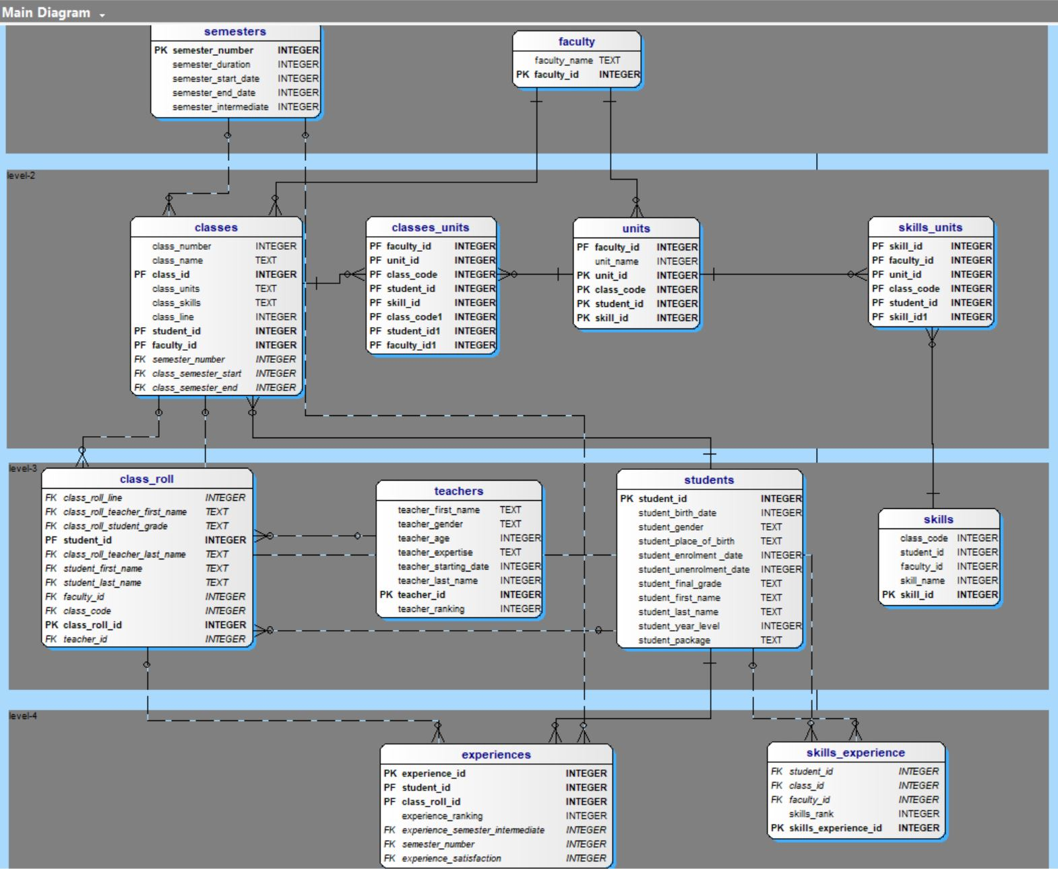

https://imgur.com/0XOSmn1

See full image: (Ctrl-click) <https://imgur.com/0XOSmn1>